GOVERNMENT OF THE DISTRICT OF COLUMBIA

Department of Energy and Environment

Lead-Safe and Healthy Housing Division
Lead Compliance & Enforcement Branch

Notice of Certification Expiration

TO: ,

,

RE: DC Certification DC22-0580

Dear , :

You are receiving this letter because your certification to conduct lead-based paint hazard identification and/or elimination activities in the District of Columbia expires on 05-16-2027. In order to maintain your certification in your particular discipline, you need to apply to be re-certified by DOEE in that discipline. In order to get re-certified, you must complete the appropriate training course, either refresher or initial as applicable, through an EPA- or DOEE- accredited training provider, or from another EPA-authorized, state-accredited training provider. You must also submit the application materials and pay the appropriate certification renewal fee to DOEE, in accordance with 20 DCMR § 3322, at least five (5) business days before their certification expires. Payment of such fee is waived for employees of a District agency.

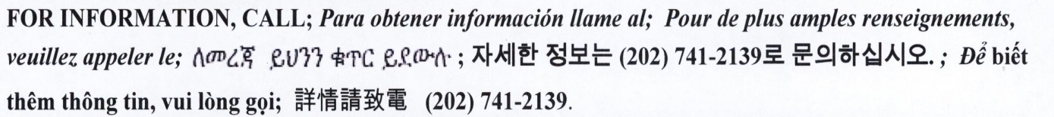
Remember if you fail to complete the refresher course before the expiration date of their current certification, as required in 20 DCMR § 3306.4, or within ninety (90) days after such expiration date, you must re-take the initial course to become certified again.
Should you have any questions, please contact Shamika Parker, Environmental Protection Specialist, between the hours of 9:00 AM and 4:00 PM at (202) 535-2637 or by email at shamika.parker@dc.gov or doee.lead@dc.gov.

Sincerely,

Shamika Parker
Environmental Protection Specialist

